What is TTT? The Tapping Heals the Trauma
When we experience trauma, our bodies may become rigid, holding in the tension or they may become floppy and start to feel like we are not really in control of them. Sometimes we start to feel disconnected from our body, we may feel repulsion towards it or indifference or many other things that make it harder to feel happy in our skin.
TTT targets areas of the body where trauma is often stored and encourage awareness and blood flow to these areas. These are points which are also stimulated in many other forms of ancient healing such as acupuncture and acupressure. The tapping calls us back to our body, the gentle tap to reawaken a playful sense of grounding and connection. Our brains respond to this tapping by reducing the amount of cortisol – the stress hormone.

How to do it?
Start on one side (I started by tapping with the right onto the left)
Make a fist or karate chop with one hand and using two fingers on the other hand tap on the bottom edge of your hand (the part which would do the karate chop). The tapping should be rhythmic and repetitive. Some people like to count out ten taps on each location, other people like to tap for longer.
Next take both hands and tap on the inside corners of the eyebrows. Once you have tapped there 10 or so times move to the outside of the eye and tap there then tap under the eye.
Use whichever is your main tapping hand in this round to then tap under the nose and then under the mouth.
Use both hands to do the gorilla tap on the collar bone. This one is particularly good for releasing trauma.
Lift your non tapping hand and use your tapping hand to tap the side of your rib cage. This one is great for happiness.
Returning to the hands tap where the nail meets the nail bed on each finger and thumb in turn.
Return to tapping the collar bone.
Clap your hands together and then rub rapidly to create some heat.
Take a deep breath as you gentle cover your eyes with your now warmer hands. After a moment breath out as you slowly trace your warm hands up over your forehead and over and round to the top of your spine.
Start again this time using your other hand as the main tapping hand.
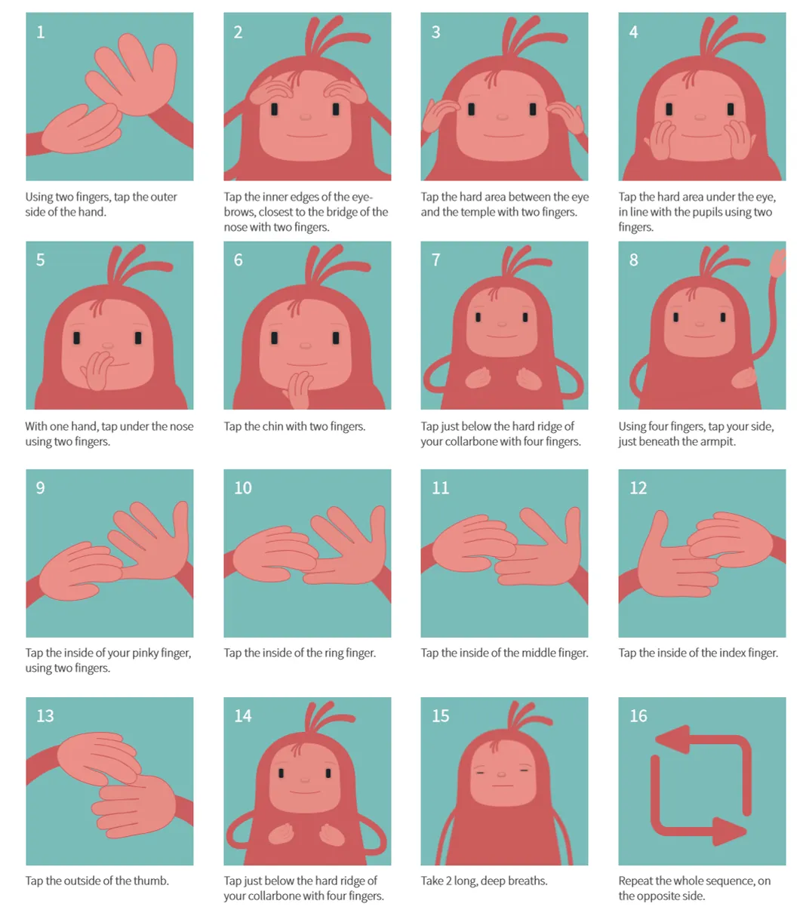
Amy Willshire/ September 12, 2019/ All posts, Dramatherapy or Dramatherapist, Lifelong Learning/ 0 comments

